**Key Features**

PRO Ultimate

Series

130MB/s Write Speed

200MB/s Read Speed

512GB

Capacity

• Spend more time creating and less time saving with read and write speeds up to 200/130 MB/s¹ when using Samsung USB readers.  
  
• Whether you’re using a smartphone or a gaming console,⁴ count on the PRO Ultimate microSD for compatibility.  
  
• With 10-year limited warranty, PRO Ultimate MicroSD is tough enough to take on anything with protection from water⁵ to extreme temps.⁶  
  
• Pile in the files and expand your portfolio with a wide range of storage options from 128GB to 512GB.

Storage

**128GB**

$36.99

**256GB**

$49.99

**512GB**

$87.99

**VIP Advantage**

**VIP Advantage membershipLearn more**

* 2 Year Samsung Care+ (without Theft and Loss)
* Exclusive Discounts & Early Access

To select this option, please sign in or create a Samsung account

**Premium Benefits**

**$149.99/yr**

**Delivery & professional services**

Availability for:

96928

Delivery

**Delivery**

Not available



**In-Store Pickup**

Not available

This product is currently not available in your area.

**Choose your purchase option**

Questions? Ask a Financing Expert

**One-time Payment**

**$87.99**

**Pay in 4 Installments**

**$22.00**

**every two weeks σπ**

**One-time payment**

Pay with your credit card, debit card or a pay app. Excludes taxes and shipping.

**PRO Ultimate + Reader microSDXC 512GB$87.99**

**Total**

**$87.99**



**Log in now to earn up to 1.5% back in Samsung Rewards Points**

**Add to cart**

[**Where to buy**](https://www.samsung.com/us/computing/memory-storage/memory-cards/pro-ultimate-reader-microsdxc-512gb-mb-my512sb-am-buy)

Supported payment types:

Credit CardPayPal Venmo Checkoutamazonpaygooglepay

**Made for expert-level endeavors**

Step into a new stage of storage with the PRO Ultimate MicroSD. It supports everything from creative pursuits to personal memories with high speed.

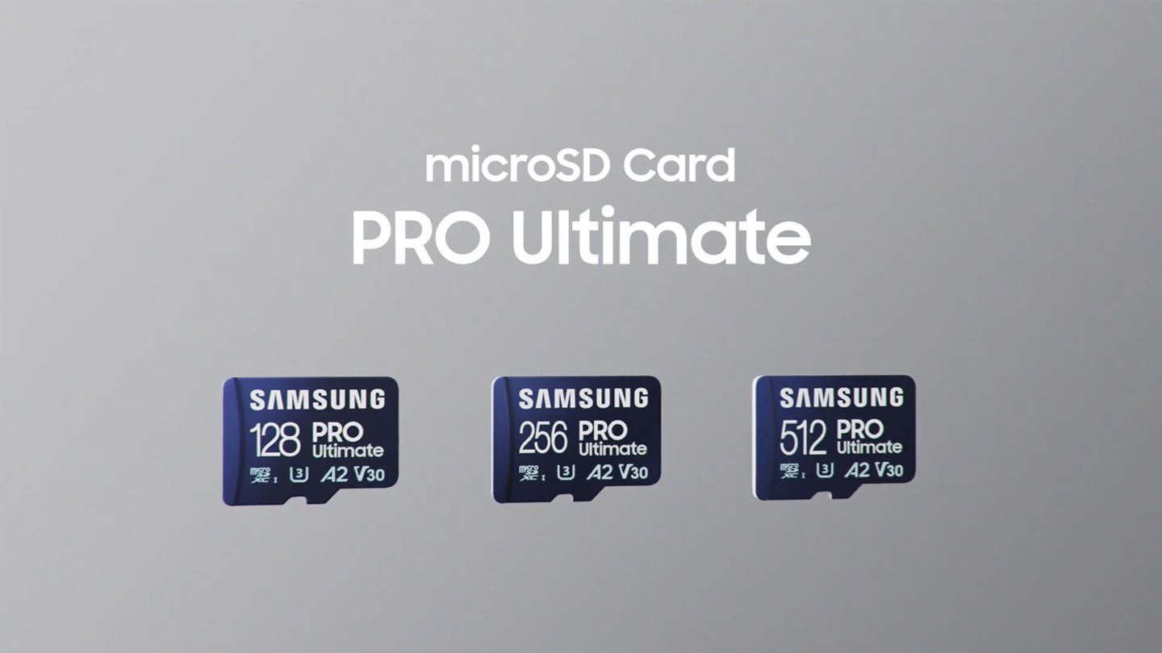



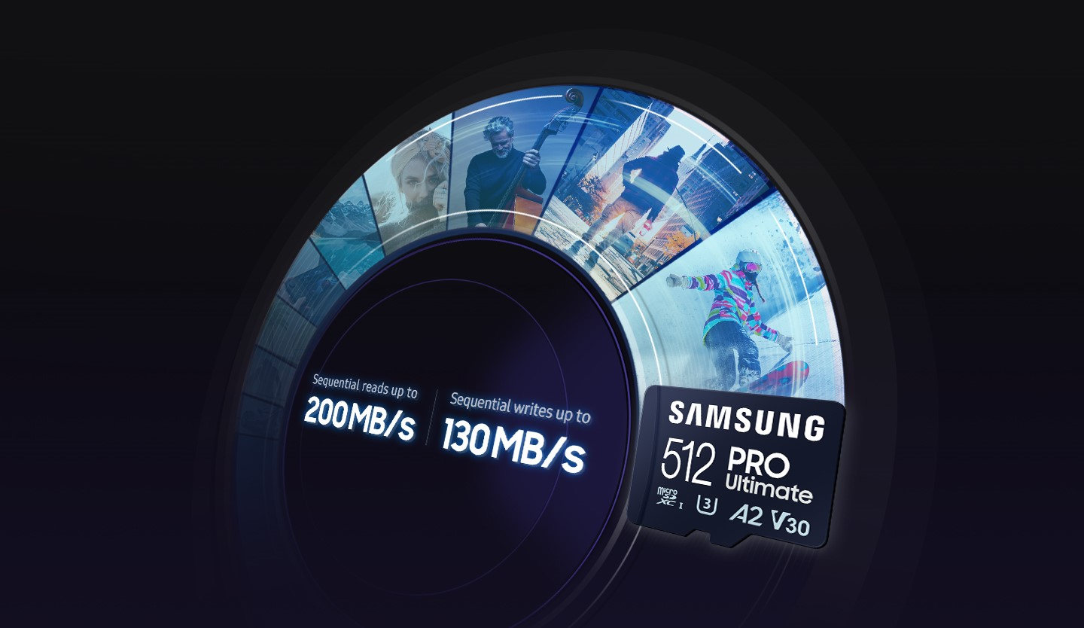

**Fast just got faster**

Read/Write Speeds up to 200/130 MB/s

The PRO Ultimate MicroSD makes it easy to complete each task. Spend more time creating and less time saving with read and write speeds up to 200/130 MB/s¹ when using Samsung USB readers. It also features state-of-the-art U3 and V30 ratings² with A2 performance³ that helps with fast loading and 4K UHD video capture.

*¹The foregoing read and write speeds are based on tests conducted under controlled conditions. Actual speeds may vary depending upon card capacity. Stated performance was achieved by using PRO Ultimate SD cards with Samsung readers.*

*²UHS Speed Class 3 designates a performance option designed to support 4K UHD video recording with enabled UHS host devices. UHS Video Speed Class 30 (V30), sustained video capture rate of 30MB/s, designates a performance option designed to support real-time video recording with UHS enabled host devices. See*[*www.sdcard.org/consumers/speed*](https://www.sdcard.org/consumers/speed)*.*

*³A2 performance is 4000 read IOPS, 2000 write IOPS.*

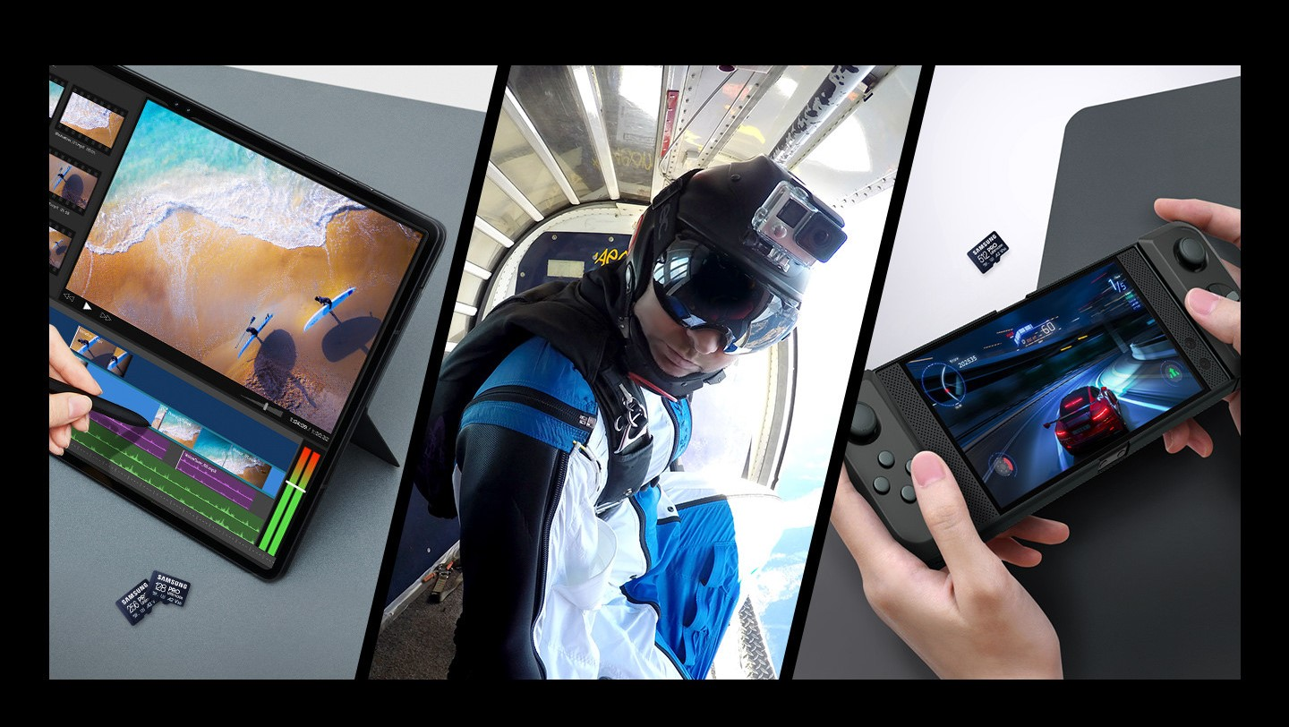

**Adapts to every need**

Extensive Compatibility

Whether you’re using a smartphone or a gaming console,⁴ count on the PRO Ultimate microSD for extensive compatibility. It a true team player when it comes to heavy-duty application usage or file-saving—and can be used with action cams and drones, too.